Academic Year 2025-26
Java Practical Assignment 2
Interfaces, Packages and Exception Handling & The Collection Framework
=============================================================
1. Create a package ShapePkg. In this package, write an interface Shape having methods area() and perimeter(). Create two classes Circle and Rectangle that implement this interface and override its methods. Write another class with main() method to create objects of both classes, accept input using Scanner, and display the results.

CODE:

package ShapePkg;

public interface Shape {

double area();

double perimeter();

}

package ShapePkg;

public class Circle implements Shape{

double radius;

public Circle(double radius)
{
this.radius=radius;
}

@Override
public double area() {
return Math.PI * radius * radius;

}

@Override
public double perimeter() {
return 2 * Math.PI * radius;

}

}

package ShapePkg;

public class Rectangle implements Shape{

double length;
double width;

public Rectangle(double length, double width)
{
this.length=length;
this.width=width;
}

@Override
public double area() {
return length * width;
}

@Override
public double perimeter() {
return 2 * (length + width);
}

}

package ShapePkg;

import java.util.Scanner;

public class ShapeMain {

public static void main(String[] args) {

Scanner sc=new Scanner(System.in);

System.out.println("Enter radius of the circle:");
double r=sc.nextDouble();

Circle c=new Circle(r);

System.out.println("Area of circle:"+c.area());
System.out.println("Perimeter of circle:"+c.perimeter());

System.out.println("\nEnter length of the rectangle:");
double l=sc.nextDouble();
System.out.println("\nEnter width of the rectangle:");
double w=sc.nextDouble();

Rectangle rect=new Rectangle(l,w);

System.out.println("Area of rectangle:"+rect.area());
System.out.println("Perimeter of rectangle:"+rect.perimeter());

}

}

OUTPUT:
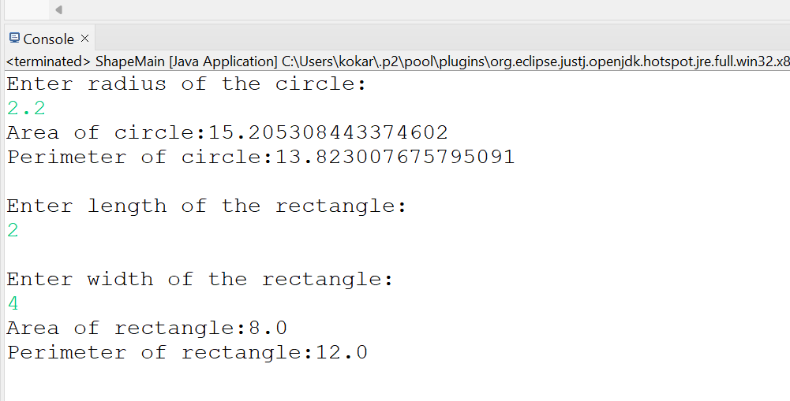

2. Create a package MultiInterfacePkg. Define two interfaces Printable and Showable with methods print() and show(). Create a class Document that implements both interfaces and provides method definitions. Write a main class to create an object of Document and call both methods.

CODE:

package MultiInterfacePkg;

public interface Printable {

public void print();

}

package MultiInterfacePkg;

public interface Showable {

public void show();

}

package MultiInterfacePkg;

public class Document implements Printable, Showable{

@Override
public void show() {

System.out.println("This is show method");

}

@Override
public void print() {

System.out.println("This is print method");

}

public static void main(String[] args) {

Document d=new Document();
d.print();
d.show();
}

}
OUTPUT:

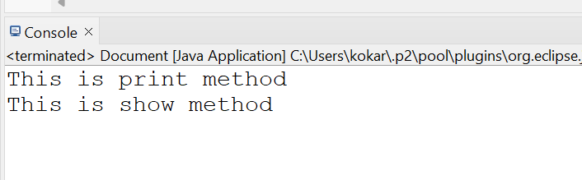

3. Create a package MathOperationsPkg. In this package, write a class Calculator with methods for addition, subtraction, multiplication, and division. Create another class in a different package to import this package and use its methods. Write the main method to perform operations based on user input.

CODE:

package MathOperationsPkg;

public class Calculator {

public int add(int a, int b)
{
return a+b;
}
public int subtract(int a, int b)
{
return a-b;
}
public int multiply(int a, int b)
{
return a*b;
}
public int divide(int a, int b)
{
return a/b;
}

}

package MainPkg;

import java.util.Scanner;

import MathOperationsPkg.Calculator;
public class MainClassTest {

public static void main(String[] args) {

Scanner sc=new Scanner(System.in);
Calculator c=new Calculator();

System.out.println("Enter first number:");
int a=sc.nextInt();
System.out.println("Enter second number:");
int b=sc.nextInt();
System.out.println("Select which operation to perform->"
+ "\n1. Addition"
+ "\n2. Subtraction"
+ "\n3. Multiplication"
+ "\n4. Division");
int op=sc.nextInt();

if(op==1)
{
System.out.println(c.add(a, b));
}
else if(op==2)
{
System.out.println(c.subtract(a, b));
}
else if(op==3)
{
System.out.println(c.multiply(a, b));
}
else if(op==4)
{
System.out.println(c.divide(a, b));
}
else {
System.out.println("Invalid input");
}

}

}

OUTPUT:
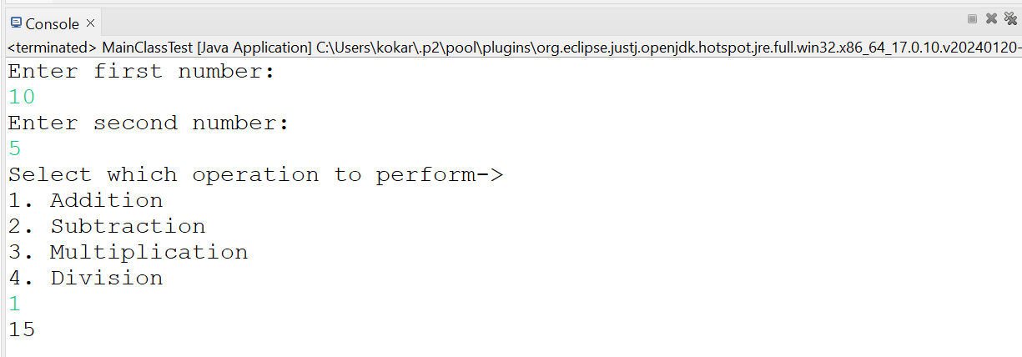

4. Create a package StudentPkg. Define a class Student with variables having different access modifiers (public, protected, default). Create another package and write a class to access these variables. Write a main method to demonstrate which members are accessible and which are not.

CODE:
package StudentPkg;

public class Student {

public int id=10;

protected String name="Sakshi";

int roll_num=2501097;

}

package MainPkg;

import StudentPkg.Student;

public class AccessVariables {

public static void main(String[] args) {

Student s=new Student();

//accessible because public
System.out.println("ID of student:"+s.id);
//not accessible because protected
//System.out.println("Name of the student:"s.name);
//not accessible because default
//System.out.println("Roll number -"s.roll_num);

}

}

OUTPUT:
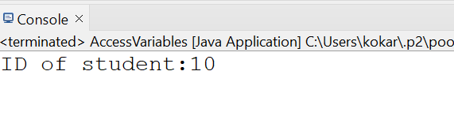

5. Create a package UtilityPkg. Write a class StringUtility with methods reverse() and toUpperCase(). Create another class that imports this package using both explicit import and wildcard import. Write a main method to call these methods and display output.

CODE:
package UtilityPkg;

public class StringUtility {

public String reverse(String str)
{
String rev="";
for(int i=str.length()-1;i>=0;i--)
{
rev=rev+str.charAt(i);
}
return rev;
}

public String toUpperCase(String str)
{
return str.toUpperCase();
}

}

package MainPkg;
import java.util.Scanner;

import UtilityPkg.*; //wildcard import
import UtilityPkg.StringUtility; //explicit import

public class TestUtility {

public static void main(String[] args) {
Scanner sc=new Scanner(System.in);

StringUtility s=new StringUtility();
System.out.println("Enter string to reverse and display in uppercase:");
String u=sc.next();

System.out.println("Reversed string-> "+s.reverse(u));
System.out.println("String in uppercase-> "+s.toUpperCase(u));

sc.close();

}

}

OUTPUT:
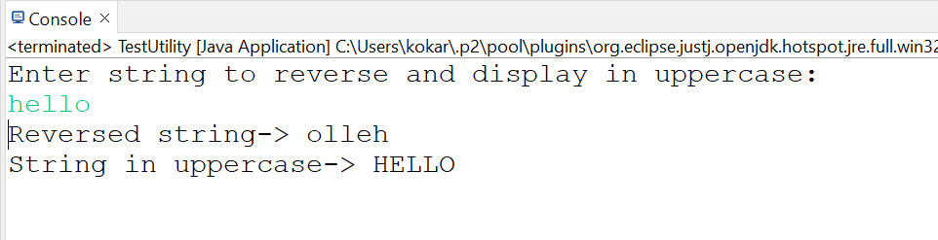

6. Create a package StudentDataPkg. Write a class Student to accept name, roll number, and marks of 3 subjects using Scanner. Calculate total and average marks. Write a main class to create object and display student details.

CODE:

package StudentDataPkg;

import java.util.Scanner;

public class Student {

int roll_num;
String name;
int m1, m2, m3;
int total_marks;
double average_marks;

public void acceptData()
{
Scanner sc=new Scanner(System.in);

System.out.println("Enter student roll number:");
roll_num=sc.nextInt();
System.out.println("Enter name of the student:");
name=sc.next();
System.out.println("Enter marks for subject 1:");
m1=sc.nextInt();
System.out.println("Enter marks for subject 2:");
m2=sc.nextInt();
System.out.println("Enter marks for subject 3:");
m3=sc.nextInt();

total_marks=m1+m2+m3;
average_marks=total_marks/3.0;
}

public void display()
{
System.out.println("Student details");
System.out.println("\nStudent roll number:"+roll_num);
System.out.println("\nStudent name:"+name);
System.out.println("\nTotal marks:"+total_marks);
System.out.println("\nAverage marks:"+average_marks);
}

}

package StudentDataPkg;

public class MainClass {

public static void main(String[] args) {

Student s=new Student();
s.acceptData();
s.display();

}

}

OUTPUT:
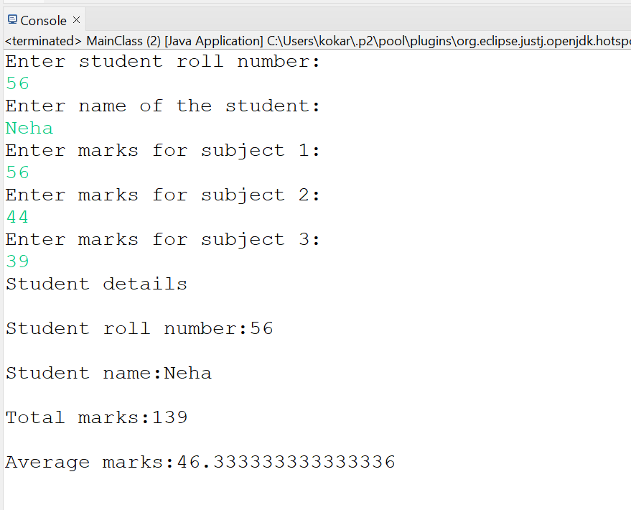

7. Create a package ExceptionPkg. Write a class Division to perform division of two numbers. Handle ArithmeticException using try-catch and use finally block to display a message. Write a main class to test the program with user input.

CODE:

package ExceptionPkg;

public class Division {

public void divison(int a, int b)
{
try {
int div=a/b;
System.out.println("Result->"+div);
} catch(ArithmeticException ae)
{
System.out.println("Message->"+ae);
}
finally {
System.out.println("Code executed successfully!");
}
}

}

package ExceptionPkg;

import java.util.Scanner;

public class Main {

public static void main(String[] args) {

Scanner sc=new Scanner(System.in);

System.out.println("Enter first number:");
int a=sc.nextInt();
System.out.println("Enter second number:");
int b=sc.nextInt();

Division d=new Division();
d.divison(a, b);

}

}

OUTPUT:
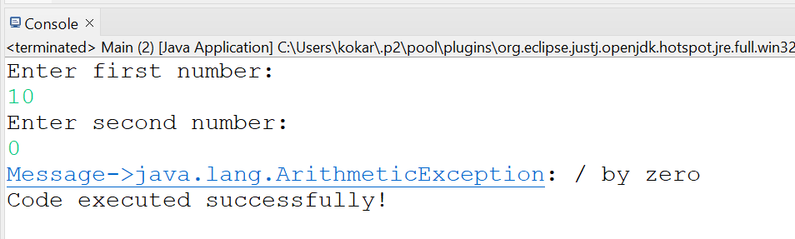

8. Create a package AgePkg. Write a class AgeValidator with a method checkAge(int age) that throws an exception if age is less than 18 using throw. Use throws in method declaration. Write a main class to call this method and handle the exception.

CODE:
package AgePkg;

public class AgeValidator {

public void checkAge(int age) throws Exception
{
if(age<18)
{
throw new Exception("Age is less than 18!");
}
else {
System.out.println("Valid age, you are eligible!");
}
}

}

package AgePkg;

import java.util.Scanner;

public class Main {

public static void main(String[] args) {

Scanner sc=new Scanner(System.in);
AgeValidator av=new AgeValidator();

try {
System.out.println("Enter your age:");
int age=sc.nextInt();
av.checkAge(age);
} catch(Exception e)
{
System.out.println("Exception:"+e.getMessage());
}

sc.close();
}
}

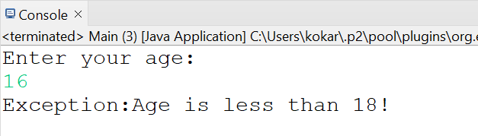

9. Create a package EmployeePkg. Define a user-defined exception class InvalidSalaryException. Write a class Employee that throws this exception if salary is below a given limit. Write a main class to accept salary input and handle the exception with a proper message.

CODE:
package EmployeePkg;

public class InvalidSalaryException extends Exception{

public InvalidSalaryException(String message)
{
super(message);
}
}

package EmployeePkg;

public class Employee {

public void checkSalary(double salary) throws InvalidSalaryException
{
if(salary<10000)
{
throw new InvalidSalaryException("Salary cannot be less than 10000");
}

System.out.println("Valid salary:"+salary);
}
}

package EmployeePkg;

import java.util.Scanner;

public class MainClass {

public static void main(String[] args) {

Scanner sc=new Scanner(System.in);
Employee e=new Employee();

try {
System.out.println("Enter employee salary:");
double salary=sc.nextDouble();

e.checkSalary(salary);
}catch(InvalidSalaryException i)
{
System.out.println("Exception:"+i.getMessage());
}
}

}

OUTPUT:
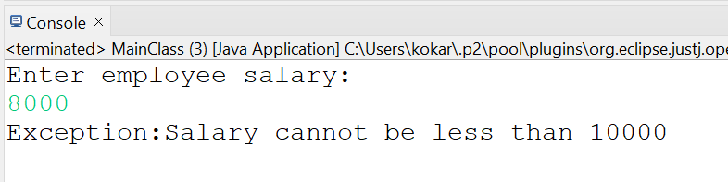

10. Create a package ArrayListPkg. In this package, write a class Student with attributes id, name, and marks. Create another class StudentManager that uses ArrayList to store multiple student objects. Include methods to add, remove, search, and display students. Write a main class to perform all operations using user input and display results.

CODE:

package ArrayListPkg;

public class Student {

int id;
String name;
int marks;

Student(int id, String name, int marks)
{
this.id=id;
this.name=name;
this.marks=marks;
}

public void display()
{
System.out.println("ID:"+id+" Name:"+name+" Marks:"+marks);
}

}

package ArrayListPkg;

import java.util.ArrayList;

public class StudentManager {

ArrayList<Student> students=new ArrayList<Student>();

public void addStudent(Student s)
{
students.add(s);
System.out.println("Student Added!");
}

public void removeStudent(int id)
{
for(Student s:students)
{
if(s.id==id)
{
students.remove(s);
System.out.println("Student Removed!");
return;
}
}
System.out.println("Student not found!");
}

public void searchStudent(int id)
{
for(Student s:students)
{
if(s.id==id)
{
s.display();
return;
}
}
System.out.println("Student not found!");
}

public void displayStudents()
{
if(students.isEmpty())
{
System.out.println("No students found!");
return;
}
for(Student s:students)
{
s.display();
}
}

}

package ArrayListPkg;

import java.util.Scanner;

public class MainApp {

public static void main(String[] args) {

Scanner sc=new Scanner(System.in);
StudentManager sm=new StudentManager();

while(true)
{
System.out.println("1. Add student");
System.out.println("2. Remove student");
System.out.println("3. Search student");
System.out.println("4. Display students");
System.out.println("5. Exit");

System.out.println("Enter choice:");
int choice=sc.nextInt();

switch(choice) {
case 1:
System.out.println("Enter student id:");
int id=sc.nextInt();
sc.nextLine();
System.out.println("Enter student name:");
String name=sc.nextLine();
System.out.println("Enter marks:");
int marks=sc.nextInt();

sm.addStudent(new Student(id, name, marks));
break;

case 2:
System.out.println("Enter student id to remove:");
int sid=sc.nextInt();
sm.removeStudent(sid);
break;

case 3:
System.out.println("Enter id to search student:");
int ssid=sc.nextInt();
sm.searchStudent(ssid);
break;

case 4:
sm.displayStudents();
break;

case 5:
System.out.println("Exiting!");
return;

default:
System.out.println("Invalid choice");

}
}

}

}

OUTPUT:
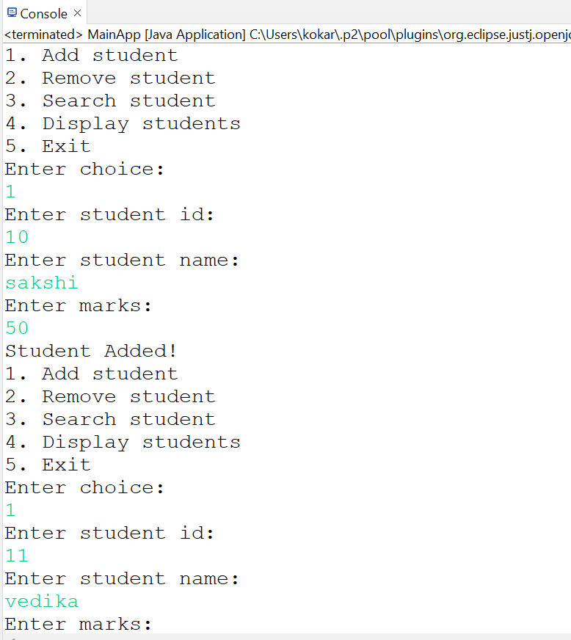
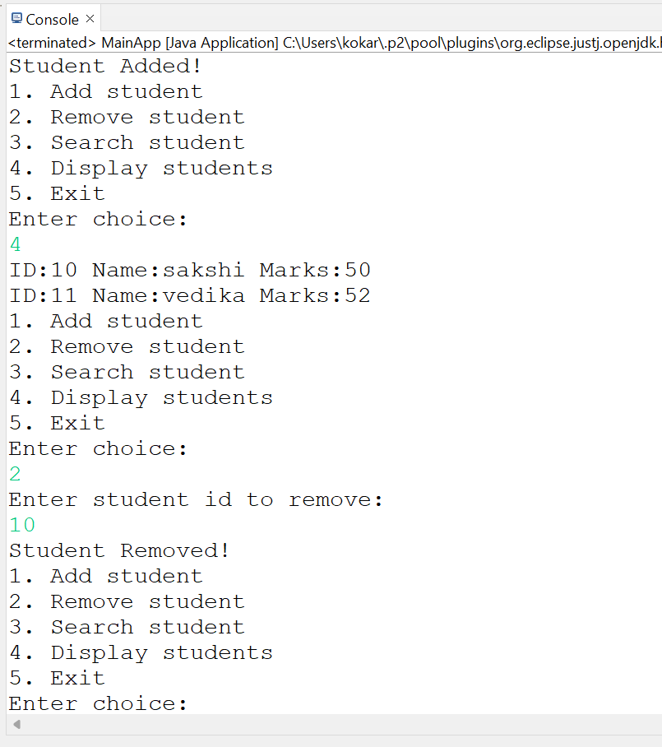
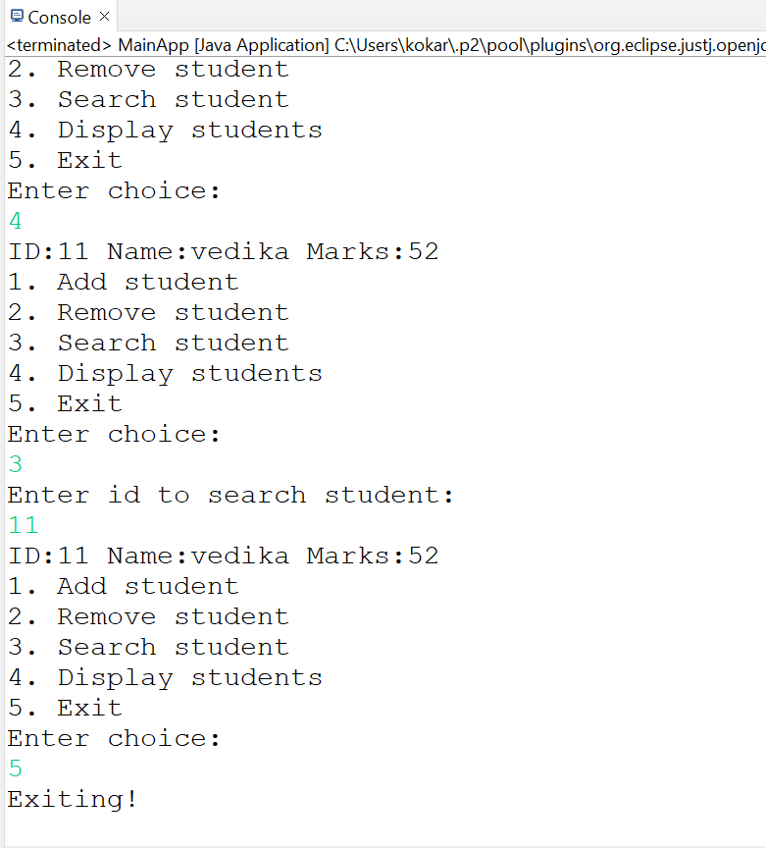

11. Create a package ArrayListSortPkg. Write a class Employee with attributes id, name, and salary. Use ArrayList to store employee objects and implement sorting based on salary using Comparator. Also filter employees with salary above a given value. Write a main class to demonstrate sorting and filtering operations.

CODE:
package ArrayListSortPkg;

public class Employee {

int eid;
String ename;
double salary;

public Employee(int eid, String ename, double salary) {

this.eid = eid;
this.ename = ename;
this.salary = salary;
}

public void display()
{
System.out.println("ID:"+eid+" Name:"+ename+" Salary:"+salary);
}

}

package ArrayListSortPkg;

import java.util.ArrayList;
import java.util.Collections;
import java.util.Comparator;
import java.util.Scanner;

public class EmployeeMain {

public static void main(String[] args) {

ArrayList<Employee> e=new ArrayList<Employee>();

e.add(new Employee(1,"Sakshi",25000));
e.add(new Employee(2,"Saurabh",20000));
e.add(new Employee(3,"Vedika",30000));
e.add(new Employee(4,"Saras",45000));
e.add(new Employee(5,"Vishal",20000));

Collections.sort(e, new Comparator<Employee>() {
@Override
public int compare(Employee o1, Employee o2) {
return Double.compare(o1.salary, o2.salary);
}
});

System.out.println("Employees sorted by salary:");
for(Employee emp:e)
{
emp.display();
}

Scanner sc=new Scanner(System.in);
System.out.println("\nEnter salary limit to filter employees:");
double d=sc.nextDouble();

System.out.println("\nEmployees with salary above "+d+" are->");
for(Employee emp:e)
{
if(emp.salary>d)
{
emp.display();
}
}
sc.close();

}

}

OUTPUT:
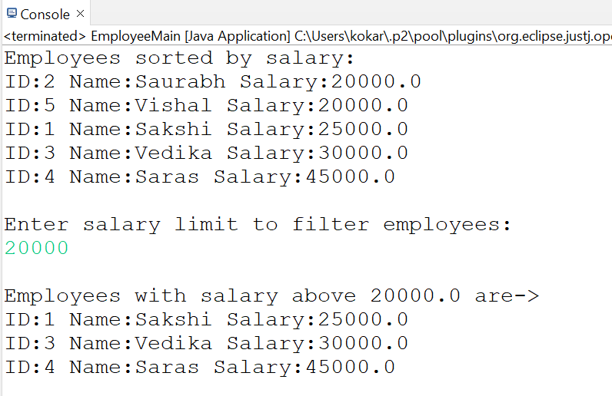

12. Create a package LinkedListPkg. Write a class Task with attributes taskId and taskName. Create a class TaskManager that uses LinkedList to manage tasks. Implement methods to add tasks at beginning/end, remove tasks, and display tasks. Write a main class to demonstrate all operations using user input.

CODE:

package LinkedListPkg;

public class Task {

int taskId;
String taskName;

public Task(int taskId, String taskName) {
this.taskId = taskId;
this.taskName = taskName;
}

public void display()
{
System.out.println("Task ID:"+taskId+" Task Name:"+taskName);
}

}

package LinkedListPkg;

import java.util.LinkedList;

public class TaskManager {

LinkedList<Task> ll=new LinkedList<Task>();

public void addTaskBeggining(Task t)
{
ll.addFirst(t);
System.out.println("Task added at first!");
}

public void addTaskLast(Task t)
{
ll.addLast(t);
System.out.println("Task added at last!");
}

public void removeTask()
{
if(ll.isEmpty())
{
System.out.println("No task available to remove.");
}
else {
ll.removeFirst();
System.out.println("Task removed!");
}
}

public void displayTasks()
{
if(ll.isEmpty())
{
System.out.println("No tasks avialable to display.");
}
for(Task t:ll)
{
t.display();
}
}
}

package LinkedListPkg;

import java.util.Scanner;

public class MainClass {

public static void main(String[] args) {

Scanner sc=new Scanner(System.in);
TaskManager tm=new TaskManager();

while(true)
{
System.out.println("Choose below options:"
+ "\n1. Add task at beggining"
+ "\n2. Add task at the end"
+ "\n3. Remove a task"
+ "\n4. Display all tasks"
+ "\n5. Exit");

int choice=sc.nextInt();

switch(choice) {
case 1:
System.out.println("Enter task id:");
int id1=sc.nextInt();
sc.nextLine();
System.out.println("Enter task name:");
String name1=sc.nextLine();
tm.addTaskBeggining(new Task(id1,name1));
break;
case 2:
System.out.println("Enter task id:");
int id2=sc.nextInt();
sc.nextLine();
System.out.println("Enter task name:");
String name2=sc.nextLine();
tm.addTaskLast(new Task(id2,name2));
break;
case 3:
tm.removeTask();
break;
case 4:
tm.displayTasks();
break;
case 5:
System.out.println("Exiting");
return;
default:
System.out.println("Invalid choice");
}
}

}

}

OUTPUT:
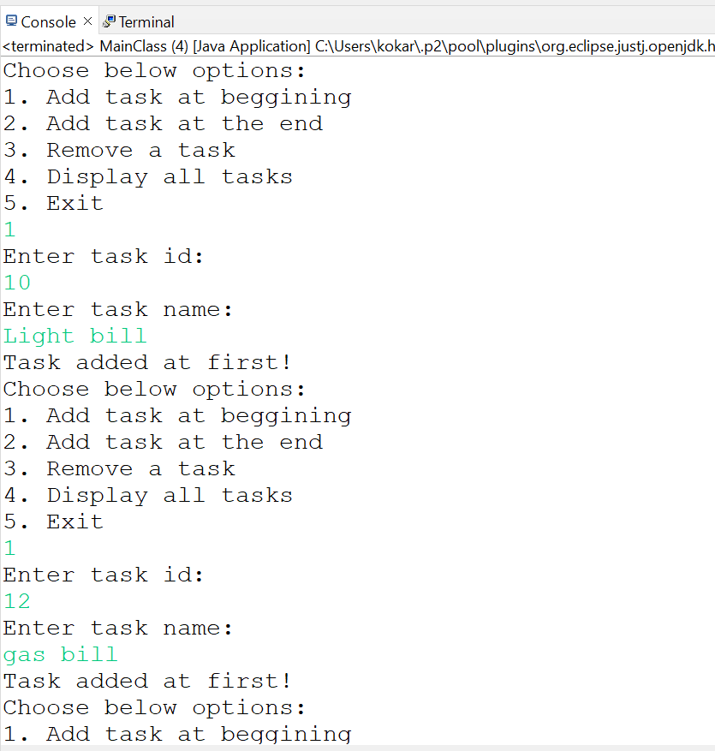
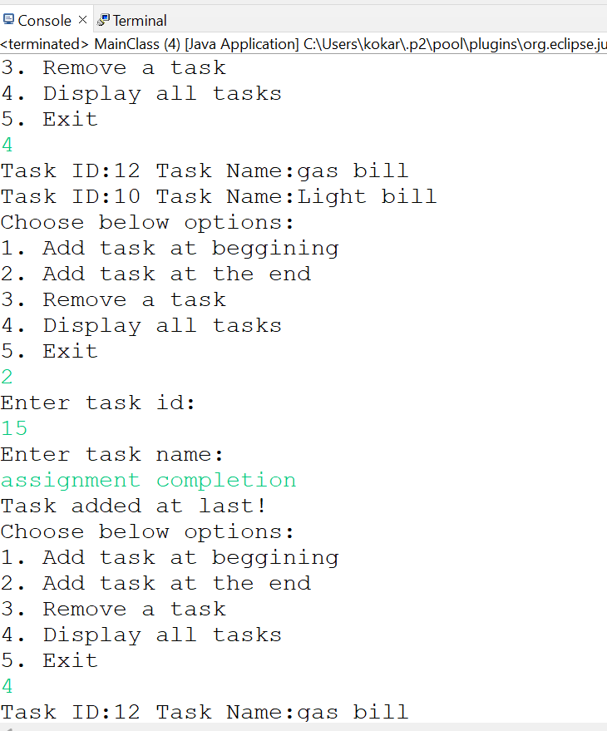
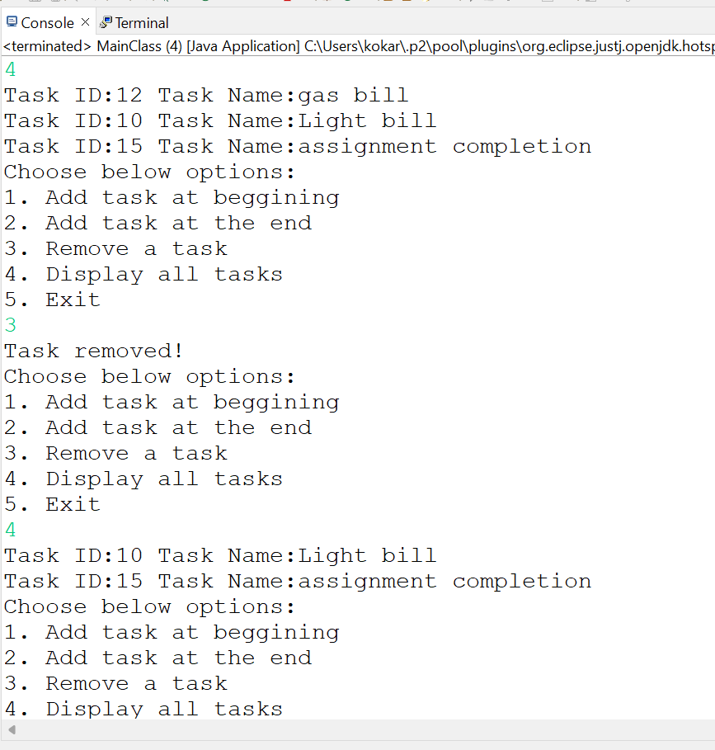

13. Create a package QueuePkg. Write a class QueueDemo that uses LinkedList to simulate queue operations like enqueue, dequeue, and peek. Handle underflow condition using exception handling. Write a main class to test queue operations.

CODE:

package QueuePkg;

import java.util.LinkedList;
import java.util.Queue;

public class QueueDemo {

Queue<Integer> ql=new LinkedList<>();

public void enqueue(int a)
{
ql.add(a);
System.out.println("Element added:"+a);
}

public void dequeue()
{
try {
if(ql.isEmpty()) {
throw new Exception("Queue is empty");
}
int val=ql.remove();
System.out.println("Element removed:"+val);
} catch(Exception e)
{
System.out.println("Exception:"+e.getMessage());
}
}

public void peek()
{
try {
if(ql.isEmpty()) {
System.out.println("Queue is empty");
}
System.out.println("Top element-"+ql.peek());
} catch(Exception e)
{
System.out.println(e.getMessage());
}
}

public void display()
{
System.out.println("Entire queue-"+ql);
}

}

package QueuePkg;

import java.util.Scanner;

import LinkedListPkg.Task;

public class MainClass {

public static void main(String[] args) {

Scanner sc=new Scanner(System.in);
QueueDemo qd=new QueueDemo();

while(true)
{
System.out.println("Choose below options:"
+ "\n1. Enqueue"
+ "\n2. Dequeue"
+ "\n3. Peek"
+ "\n4. Display"
+ "\n5. Exit");

int choice=sc.nextInt();

switch(choice) {
case 1:
System.out.println("Enter a number:");
int num=sc.nextInt();
qd.enqueue(num);
break;
case 2:
qd.dequeue();
break;
case 3:
qd.peek();
break;
case 4:
qd.display();
break;
case 5:
System.out.println("Exiting");
return;
default:
System.out.println("Invalid choice");
}
}
}

}

OUTPUT:
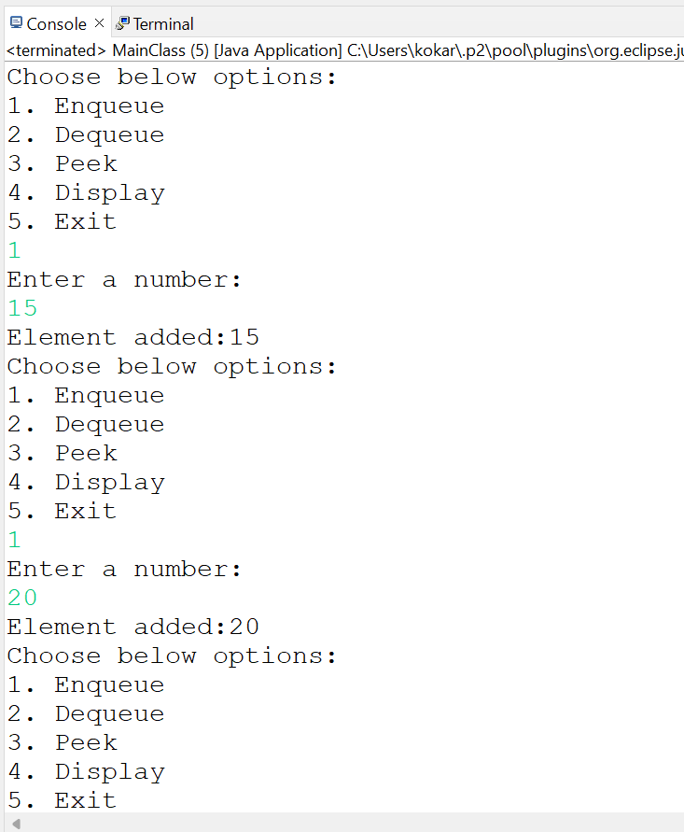
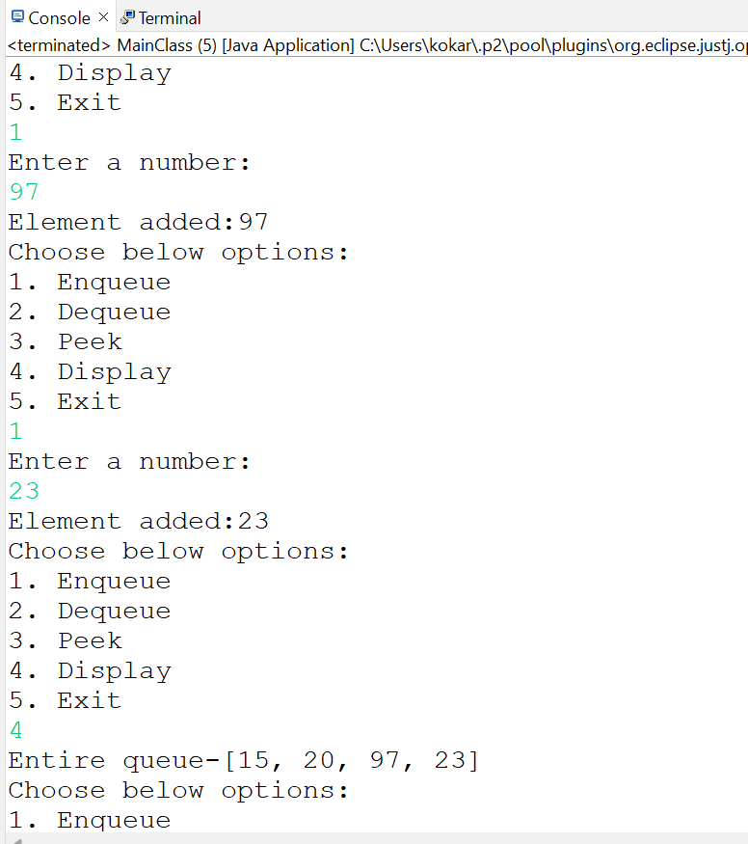
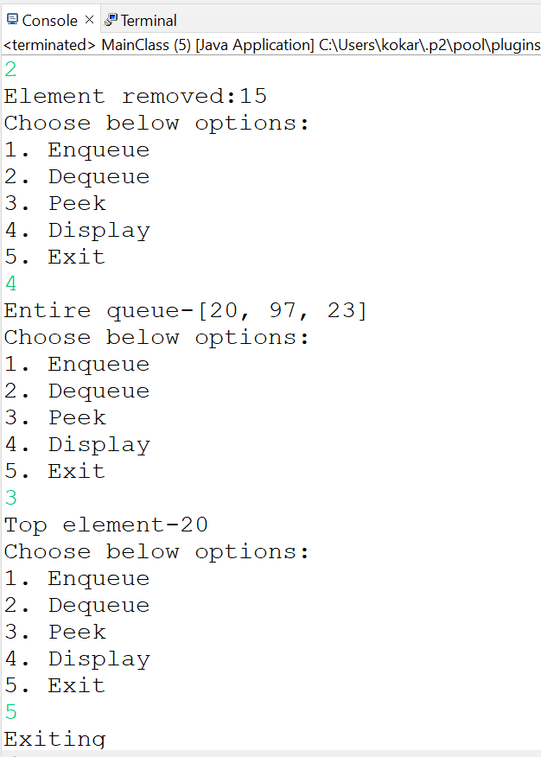

14. Create a package VectorPkg. Write a class Product with attributes id, name, and price. Use Vector to store product objects and demonstrate thread-safe operations by adding and removing elements. Write a main class to perform operations and display results.
CODE:
package VectorPkg;

public class Product {

int id;
String name;
double price;

public Product(int id, String name, double price) {
this.id = id;
this.name = name;
this.price = price;
}

public void display()
{
System.out.println("ID:"+id+" Name:"+name+" Price:"+price);
}

}
package VectorPkg;

import java.util.Scanner;
import java.util.Vector;

public class ProductMain {

public static void main(String[] args) {

Vector<Product> vp=new Vector<Product>();
Scanner sc=new Scanner(System.in);

while(true)
{
System.out.println("Choose below options:"
+ "\n1. Add"
+ "\n2. Remove"
+ "\n3. Display"
+ "\n4. Exit");

int choice=sc.nextInt();

switch(choice) {
case 1:
System.out.println("Enter product id:");
int id=sc.nextInt();
sc.nextLine();
System.out.println("Enter product name:");
String name=sc.nextLine();
System.out.println("Enter product price:");
double price=sc.nextDouble();
vp.add(new Product(id,name,price));
break;
case 2:
if(vp.isEmpty())
{
System.out.println("No products available");
}else {
vp.remove(vp.size()-1);
System.out.println("Last product removed");
}
break;
case 3:
if(vp.isEmpty())
{
System.out.println("No products available");
}else {
for(Product p:vp)
{
p.display();
}
}
break;
case 4:
System.out.println("Exiting");
return;
default:
System.out.println("Invalid choice");
}
}

}

}

OUTPUT:
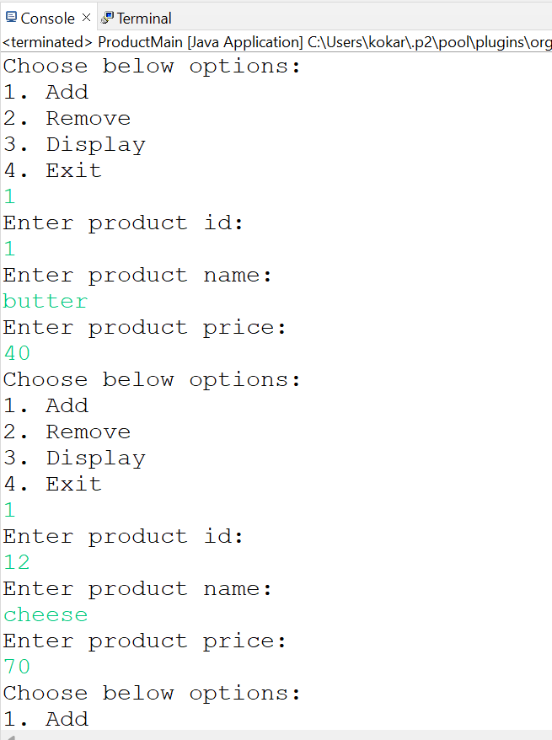
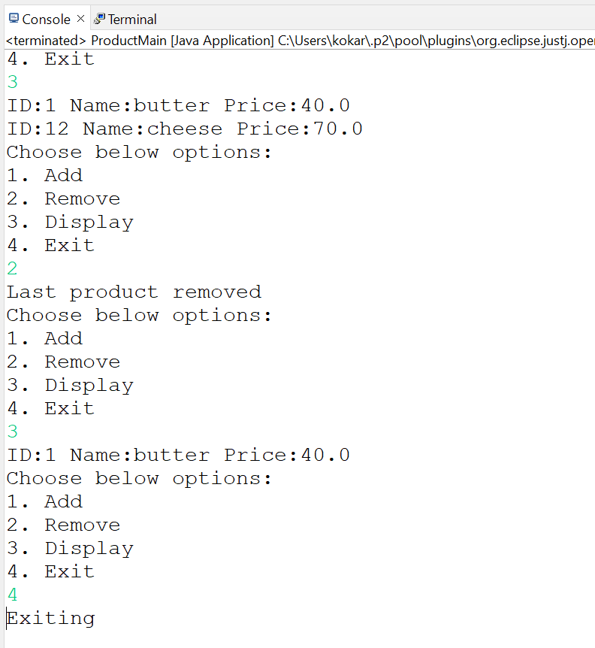

15. Create a package StackPkg. Write a class StackDemo that uses Stack to evaluate a postfix expression. Implement push, pop, and peek operations and handle empty stack using exception handling. Write a main class to input expression and display result.

CODE:

package StackPkg;

import java.util.Stack;

public class StackDemo {

Stack<Integer> stack=new Stack<Integer>();

public void push(int a)
{
stack.push(a);
}

public int pop() throws Exception
{
if(stack.isEmpty())
{
throw new Exception("Stack is empty");
}
return stack.pop();
}

public int peek() throws Exception
{
if(stack.isEmpty())
{
throw new Exception("Stack is empty");
}
return stack.peek();
}

public int evaluatePostfix(String exp) throws Exception {

for(int i = 0; i < exp.length(); i++) {

char ch = exp.charAt(i);

if(Character.isDigit(ch)) {
push(ch - '0'); // convert char to integer
}
else {

int b = pop();
int a = pop();

switch(ch) {
case '+':
push(a + b);
break;

case '-':
push(a - b);
break;

case '*':
push(a * b);
break;

case '/':
push(a / b);
break;
}
}
}
return pop();
}
}

package StackPkg;

import java.util.Scanner;

public class MainStack {

public static void main(String[] args) {
Scanner sc = new Scanner(System.in);
StackDemo sd = new StackDemo();

try {

System.out.print("Enter Postfix Expression: ");
String exp = sc.nextLine();

int result = sd.evaluatePostfix(exp);

System.out.println("Result: " + result);

} catch(Exception e) {
System.out.println("Error: " + e.getMessage());
}

sc.close();
}

}

OUTPUT:
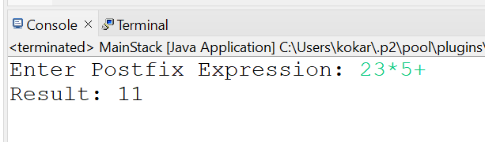

16. Create a package HashSetPkg. Write a class Course with attributes courseId and courseName. Use HashSet to store course objects and ensure no duplicate entries are allowed. Override equals() and hashCode() methods. Write a main class to add and display unique courses.

CODE:
package HashSetPkg;

public class Course {

int id;
String name;

public Course(int id, String name) {
this.id = id;
this.name = name;
}

public void display()
{
System.out.println("ID:"+id+" Name:"+name);
}

@Override
public boolean equals(Object obj) {
if(this == obj) return true;

if(obj == null || getClass() != obj.getClass()) return false;

Course c = (Course) obj;

return id == c.id;
}

@Override
public int hashCode() {
return id;
}
}

package HashSetPkg;

import java.util.HashSet;

public class CourseMain {

public static void main(String[] args) {

HashSet<Course> courses = new HashSet<>();

courses.add(new Course(101, "Java"));
courses.add(new Course(102, "Python"));
courses.add(new Course(103, "Data Structures"));
courses.add(new Course(101, "Java")); // duplicate

System.out.println("Unique Courses:");

for(Course c : courses) {
c.display();
}

}

}

OUTPUT:
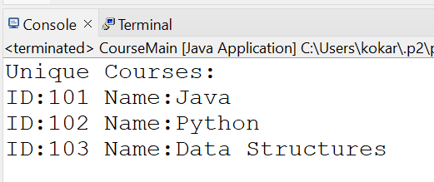

17. Create a package LinkedHashSetPkg. Write a class Book with attributes bookId and bookName. Use LinkedHashSet to store book objects and maintain insertion order while avoiding duplicates. Write a main class to demonstrate insertion and display order.

CODE:
package LinkedHasSetPkg;

public class Book {

int bookId;
String bookName;

public Book(int bookId, String bookName) {
this.bookId = bookId;
this.bookName = bookName;
}

public void display() {
System.out.println("Book ID: " + bookId + " Book Name: " + bookName);
}

@Override
public boolean equals(Object obj) {

if(this == obj) return true;

if(obj == null || getClass() != obj.getClass()) return false;

Book b = (Book) obj;

return bookId == b.bookId;
}

@Override
public int hashCode() {
return bookId;
}
}

package LinkedHasSetPkg;

import java.util.LinkedHashSet;

public class BookMain {

public static void main(String[] args) {
LinkedHashSet<Book> books = new LinkedHashSet<>();

books.add(new Book(1, "Java Programming"));
books.add(new Book(2, "Python Basics"));
books.add(new Book(3, "Data Structures"));
books.add(new Book(1, "Java Programming")); // duplicate

System.out.println("Books in insertion order:");

for(Book b : books) {
b.display();
}

}

}

OUTPUT:
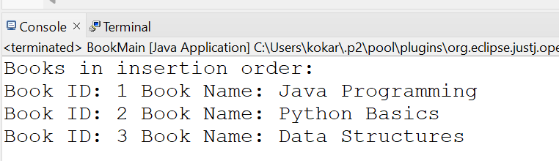

18. Create a package TreeSetPkg. Write a class Player with attributes id and score. Use TreeSet to store player objects in sorted order based on score using Comparable. Write a main class to add players and display sorted output.

CODE:
package TreeSetPkg;

public class Player implements Comparable<Player>{

int id;
int score;

public Player(int id, int score) {
this.id = id;
this.score = score;
}

public void display() {
System.out.println("Player ID: " + id + " Score: " + score);
}

@Override
public int compareTo(Player p) {
return this.score - p.score; // sorting by score
}

}

package TreeSetPkg;

import java.util.TreeSet;

public class PlayerMain {

public static void main(String[] args) {

TreeSet<Player> players = new TreeSet<>();

players.add(new Player(101, 80));
players.add(new Player(102, 95));
players.add(new Player(103, 70));
players.add(new Player(104, 85));

System.out.println("Players Sorted by Score:");

for(Player p : players) {
p.display();
}

}

}

OUTPUT:
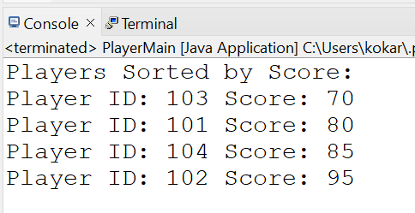

19. Create a package TreeMapPkg. Write a class Library that uses TreeMap to store book ID and book name as key-value pairs. Implement operations like add, remove, search, and display entries in sorted order of keys. Write a main class to perform all operations using user input.

CODE:
package TreeMapPkg;

import java.util.TreeMap;

public class Library {

TreeMap<Integer, String> books = new TreeMap<>();

// Add book
public void addBook(int id, String name) {
books.put(id, name);
System.out.println("Book added successfully.");
}

// Remove book
public void removeBook(int id) {
if(books.containsKey(id)) {
books.remove(id);
System.out.println("Book removed.");
} else {
System.out.println("Book ID not found.");
}
}

// Search book
public void searchBook(int id) {
if(books.containsKey(id)) {
System.out.println("Book Found: " + books.get(id));
} else {
System.out.println("Book not found.");
}
}

// Display books
public void displayBooks() {
System.out.println("Books in sorted order of ID:");

for(Integer id : books.keySet()) {
System.out.println("Book ID: " + id + " Book Name: " + books.get(id));
}
}
}

package TreeMapPkg;

import java.util.Scanner;

public class LibraryMain {

public static void main(String[] args) {

Scanner sc = new Scanner(System.in);
Library lib = new Library();

int choice;

do {
System.out.println("\n1.Add Book");
System.out.println("2.Remove Book");
System.out.println("3.Search Book");
System.out.println("4.Display Books");
System.out.println("5.Exit");

System.out.print("Enter choice: ");
choice = sc.nextInt();

switch(choice) {

case 1:
System.out.print("Enter Book ID: ");
int id = sc.nextInt();
sc.nextLine();

System.out.print("Enter Book Name: ");
String name = sc.nextLine();

lib.addBook(id, name);
break;

case 2:
System.out.print("Enter Book ID to remove: ");
id = sc.nextInt();
lib.removeBook(id);
break;

case 3:
System.out.print("Enter Book ID to search: ");
id = sc.nextInt();
lib.searchBook(id);
break;

case 4:
lib.displayBooks();
break;

case 5:
System.out.println("Exiting...");
break;

default:
System.out.println("Invalid choice");
}

} while(choice != 5);

sc.close();

}

}

OUTPUT:




